**NS3 Task**

**128**

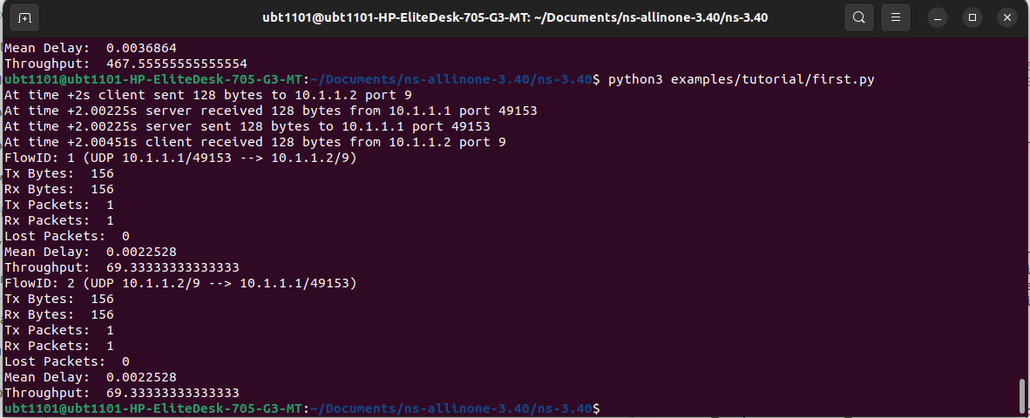

256

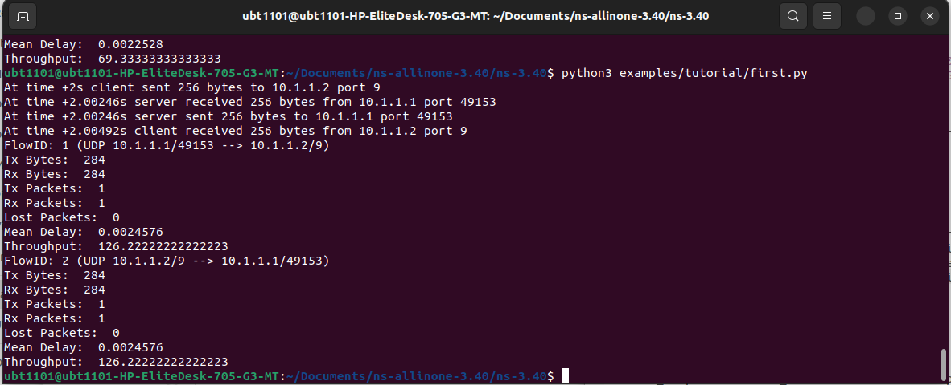

512

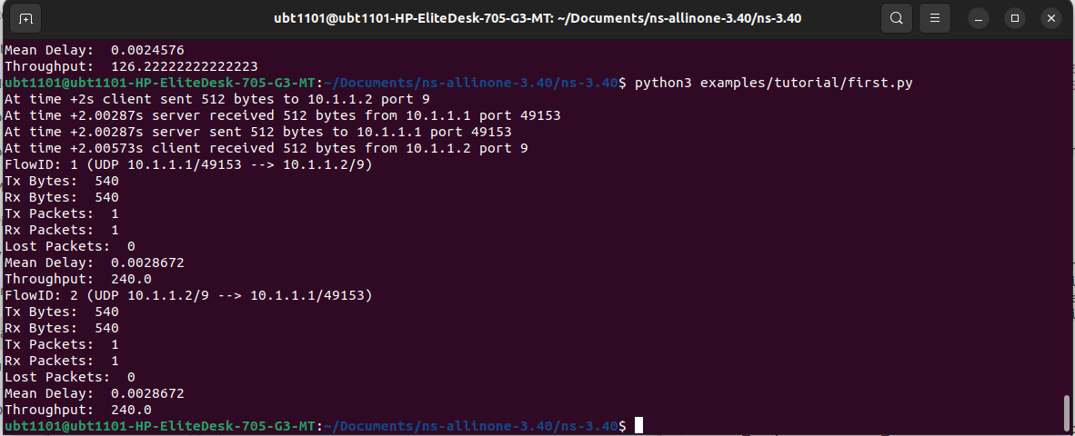

1024

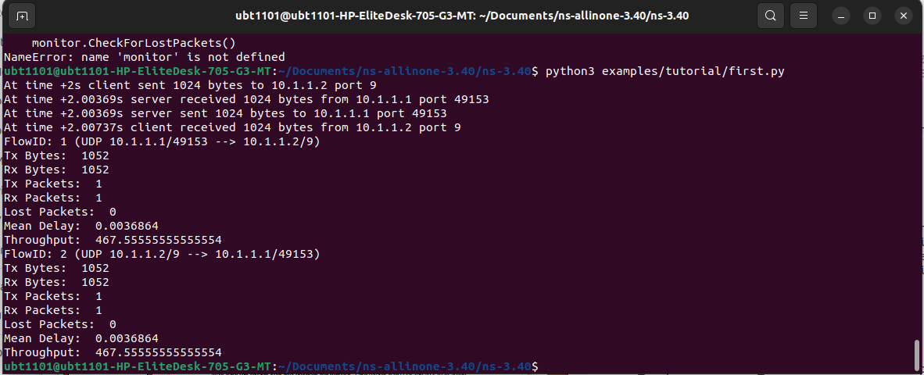

2048

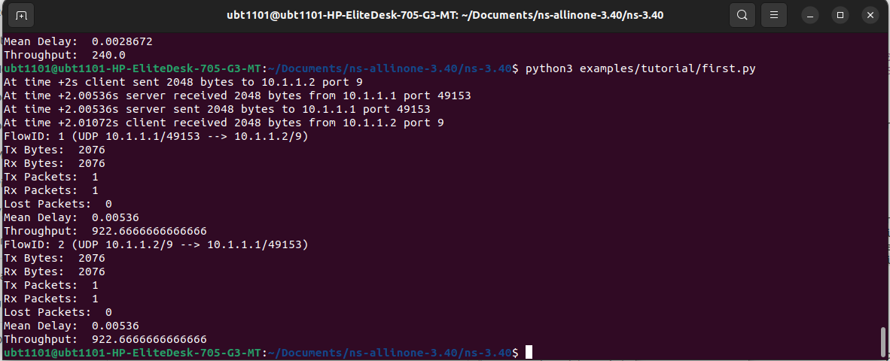

Graph : Throughput in the y-axis and data size in the x-axis.

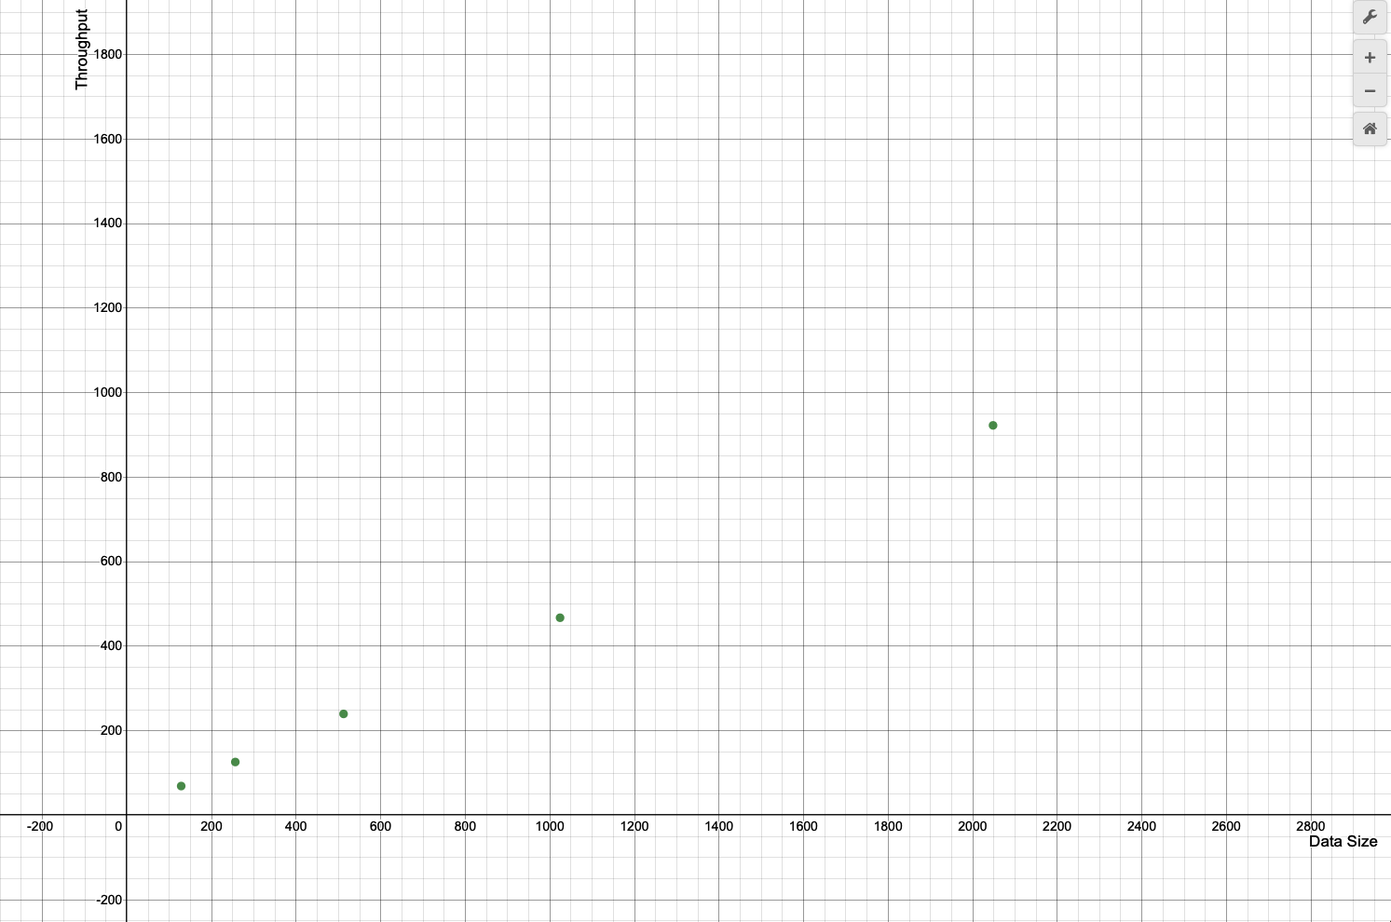

In the graph above, the throughput is plotted on the y axis which is our dependent variable and the data size plotted on the x axis which is our independent variable, and we varied the data size on the first.py file on each run to see how the throughput varies on increasing data sizes. We can see from the graph that throughput has a positive correlation with data size, and throughput only increases as data size increases.